Find Tangent Surfaces API Program

This is a great little API program that will find connected tangent surfaces of any solid or connected sheet solid. Once run, the API will ask you for one surface, it then builds a list of all surfaces connected to the first, and checks each one to see if it is tangent, it keeps building up FEMAP Set of connected tangent surfaces. It basically walks across the surfaces of a solid until it gets to a sharp break and stops walking.

Example:

Load the included Solid Edge Part file shield1.par –

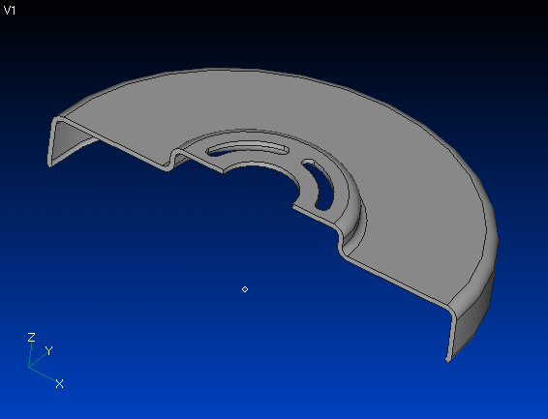

In this example, let’s say we wanted to pick all the outside surfaces of this solid, run the script and select any single outside face –

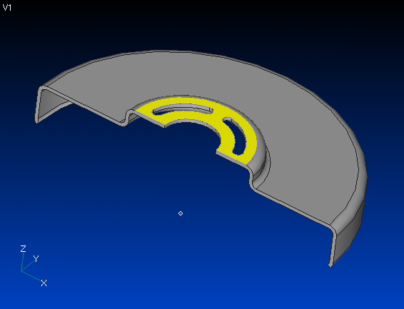

The script will find all connected tangent faces and turn them red –

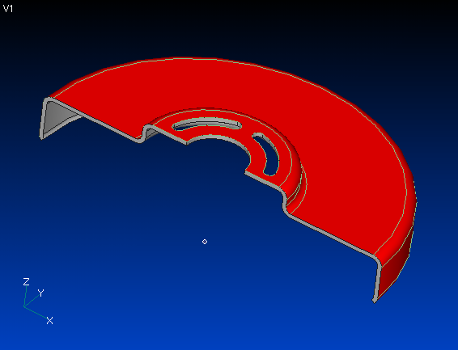

Without going around the corners. We can now use the fact that they are red and mesh only these faces – set the mesh sizing, and then use

Mesh – Geometry – Surface

In the Entity Selection Dialog Box, change the method to Color and then pick one red surface and FEMAP will automatically select the rest –

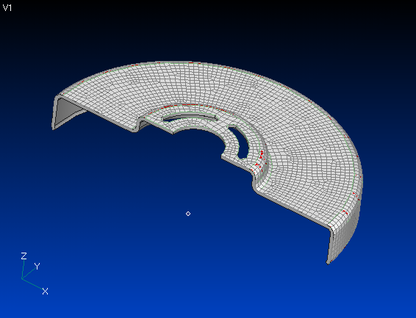

You could also offset all the red surfaces for a quick mid-plane –

